INCARNATION: A VISION OF DESIGN FROM ITS ORIGIN

by

Siyun Xue

A thesis submitted in partial fulfillment
of the requirements for the Master of Fine Arts
degree in Art (Three-Dimensional Design) in the
Graduate College of
The University of Iowa

May 2026

Thesis Committee: Monica Correia, Thesis Supervisor
Dorothy Johnson
Lonna Huisingh
Vakhtangi Darjania

Copyright by

SIYUN XUE

Choose an item.

All Rights Reserved

PUBLIC ABSTRACT
This thesis examines design through a lens that is both historical and practical. Today, design is often treated as a tool for solving commercial problems, but this view is only a small part of its longer history. From the late nineteenth century through the twentieth century, designers worked with a wide range of aims—social, political, aesthetic, and speculative. Their work shows that design has never been limited to market needs.
To understand this broader field, the thesis proposes a simple idea: design can be understood as a practice of incarnation. In this account, design is not about expressing a theme but about giving it material existence. A concept becomes real either in the designed object itself or in its user. This view helps clarify how design differs from expressive art and why the two sometimes overlap.
Several of my own works are presented as case studies. Each project begins with a theme—such as consolation, solemnity, continuity, or compound vision—and explores how that theme can be made real in an designed object or its users. Through these examples, the thesis shows how design practice as incarnation can move from a theoretical account to a concrete method.
By recovering the plurality of design’s past and by articulating a clear account of incarnation, this thesis argues for a more expansive understanding of what design can do today. Rather than serving only commercial purposes, design can once again become a field that engages ideas, reshapes lives, and opens new possibilities for the future.

TABLE OF CONTENTS
LIST OF FIGURES vi
CHAPTER 1: THE PLURALITY OF DESIGN AND THE PRACTICE OF INCARNATION 1
1.1. The Historical Plurality of Design Practice 1
1.2. Design as the Practice of Incarnation 4
1.3. The Difference Between Design and Expressive Art 6
1.4. A Statement of My Work 8
CHAPTER 2: CASE STUDIES IN INCARNATION 9
2.1. Embrace Chair: Consolation 9
2.2. Chair of Solemnity: A Solemn Way of Living 11
2.3. String Chair: Linear Continuity 13
2.3.1. Joining Steel Tubing without Welding 14
2.3.2. Joining Wire Ropes to Steel Tubing 15
2.4. PolyEye Divider: Compound Vision and Modularization 17
2.4.1. From Jewelry to Architecture: Scaling and Modularization 18
THE VISION: RETURNING TO PLURALISTIC INCARNATION 20
REFERENCES 21

LIST OF FIGURES
Figure 1 Bird in Space & Superleggera chair 6
Figure 2 The Making of a Fresco Showing the Building of a City & The Shaker Table 7
Figure 3 Perspective View of The Embrace Chair 9
Figure 4 Front View of The Embrace Chair 10
Figure 5 A Rendered Lifestyle Image 11
Figure 6 Side View of Chair of Solemnity 12
Figure 7 The Linear Structure of The String Chair in the Sunset 13
Figure 8 Aluminum Rivets Used to Join Steel Tubes Without Welding 14
Figure 9 Railing Posts Hardware 15
Figure 10 Detail of the Stringing Mechanism 16
Figure 11 Compound Vision Achieved by PolyEye Divider 17
Figure 12 Compound Eye Monocle 18
Figure 13 Magnifier Frame Hardware 18
Figure 14 The Comparison of Two Modular Designs 19

THE PLURALITY OF DESIGN AND THE PRACTICE OF INCARNATION
Today, design is often understood through its connection to commerce and marketing: it is expected to support production, generate economic value, and respond to consumer needs. This framing is so pervasive that it is treated as an inherent property of design itself. Yet a historical examination reveals that the exclusive linkage between design and commercial interests is a relatively recent development. For much of the 19th and 20th century, design operated with a wide range of motivations—social, political, aesthetic, and speculative—that cannot be reduced to commercial interests.

The Historical Plurality of Design Practice
When design began to differentiate itself from fine art in the late nineteenth and early twentieth centuries, this shift unfolded within a broader constellation of movements that positioned design as a site of cultural and social reform. The Arts and Crafts movement, for example, treated design as a response to the alienation produced by industrialization. William Morris’s workshops and writings articulated a model of design grounded in ethically organized labor and honest treatment of materials. These concerns were not aligned with market expansion; they constituted a critique of industrial capitalism and a proposal for alternative modes of living. (Pevsner, Chapter II)
The Bauhaus extended this orientation by framing design as a pedagogical project and a practice that actively participates in the shaping of modern life. Although Bauhaus objects later became associated with modernist consumer culture, the school’s founding principles were not commercial. Its curriculum sought to integrate different disciplines of art, craft, and technology in order to shape “a new architecture” — “the new structure of the future … which will one day rise toward heaven from the hands of a million workers like the crystal symbol of a new faith.” (Gropius, 49-50) Here, the “new faith” invoked in the Manifesto refers not to religion but to the emerging social ethos of modernity.
During the same period, design also intersected with politics. Russian Constructivists treated design as a means of shaping collective consciousness in the aftermath of revolution. Through material and structure, they translated abstract political values into concrete formal expressions. In this context, design functioned as a mode of political articulation. (Kiaer, 1)
Mid-century modernism in the United States and Latin America further expanded design’s conceptual scope. Designers such as Charles and Ray Eames and Alvar Aalto approached design as a cultural and social practice. Their work addressed questions of domesticity and public engagement. Even when their designed objects entered mass production, the motivations underlying their design were not reducible to economic efficiency. They sought to shape ways of living and to construct new forms of social participation. (Schildt, 67-71; Neuhart.14-5)
The most explicit challenge to commercial design emerged in the 1960s and 70s with the rise of Radical Design in Italy and speculative architecture in the United Kingdom. Groups such as Archigram, Archizoom, Superstudio interrogated consumerism with their design. Their projects were often intentionally unrealizable. These works did not aim to enter the market; they aimed to expose market’s assumptions and to imagine conditions beyond it. (Hart Design Selection, n.d.; Sparke, 171-172; Sadler, Introduction)
The above pluralistic design practices unfolded during a period—from the late nineteenth century to the end of the Cold War—in which the global landscape was shaped by competing political and economic systems. Design was shaped by this plurality and often served as a site where divergent visions of the future were articulated. Designers could align themselves with social reform, technological utopianism, political critique, or aesthetic experimentation. The field was not unified by a single purpose but animated by multiple and sometimes incompatible ambitions.
The end of the Cold War altered this landscape. As capitalism became the dominant global framework, alternative value systems lost institutional support. Design was increasingly integrated into corporate innovation pipelines, and its legitimacy became tied to measurable outcomes such as efficiency and profitability. The pluralism that had characterized earlier design practice narrowed into a single dominant orientation. The field shifted from exploring multiple possibilities to reinforcing one: the production of useful, market-ready objects. (Dunne & Raby, Chapter I)
Recovering this history is essential for understanding the present. The current alignment between design and commerce is a contingent outcome of late-twentieth-century political and economic transformations. For most of its history, design has been a site of experimentation, speculation, and ideological engagement. It addressed questions that exceeded the logic of the market and proposed alternative ways of organizing material and social life. Recognizing this plurality provides the conceptual ground for rethinking what design might do today if it were not constrained by the narrow demands of commercial utility.

Design as the Practice of Incarnation
When our view of design is not confined to the narrow frame of contemporary commercial practice but expands to the broader landscape of 19th & 20th century design history, a different picture comes into view. What becomes visible is not a single, unified trajectory but a remarkably diverse field of design practices. This historical plurality shows that design cannot be defined simply as market-oriented problem-solving. Instead, the plurality invites us to reconsider what design fundamentally is. The account I propose is to understand design as the intentional practice of incarnation. Here, I do not employ the term “Incarnation” in its original theological sense, but rather in its extended meaning—as a process through which an abstract concept acquires material existence. For a concept X, design creates something through which X acquires material existence.
While terms such as realization and embodiment might appear close to what I intend, they are either too general or fail to convey the correct relation between concept and material. Realization emphasizes the achievement of a goal, yet a goal need not be a concept, nor does its realization necessarily entail the acquisition of material existence. In this way, it risks reducing design to a generic act of execution. For example, I wanted to travel to Paris, and eventually I bought a ticket and arrived there. The realization of traveling to Paris is not a design practice, because it is driven by a wish rather than a concept. Another example is that a mathematician may begin with a concept for solving a problem by means of a specific method and, after sustained effort, achieve the solution. Yet this endeavor is also not an instance of design, since the development of the concept does not grant it material existence.
Embodiment, in turn, underscores the articulation of a concept through material form, implying the object serves as a medium of expression. Yet it still suggests a distance between the concept and the object, as if the former were external to the latter. By contrast, incarnation conveys a stronger sense of identity: There is an object that does not simply express a concept but become its material existence. For a theme X, design creates something through which X acquires a material existence.
Under this view, the plurality of design practice in history results from the plurality of themes that designers have sought to incarnate. Designers in the 19th and 20th century explored the incarnation of a wide range of themes. Modernist designers treated rationality, clarity, and universality as attributes to be incarnated. Constructivists sought to incarnate collectivism and technological futurity. Radical designers in the 1960s and 1970s attempted to incarnate critique itself.
Then, the history of design after the end of the Cold War can be understood as a transition from a plurality of themes of designers’ interest to a single dimension. As market-led capitalism became the dominant global framework, the range of themes that design was expected to incarnate narrowed significantly. Utility—understood as functional efficiency and market viability—became the primary, and often the only, theme that design was asked to incarnate. Other qualities that had previously animated design practice—such as social reform, technological speculation, political critique, or aesthetic inquiry—were increasingly marginalized. The field moved toward a one-dimensional conception of design in which the value of a designed object was measured by its utility rather than by the broader concepts it incarnates.

The Difference Between Design and Expressive Art
An account of design practice as incarnation also clarifies how design differs from expressive art. Expressive art operates through representation rather than incarnation. To create a work of expressive art is to evoke, symbolize, or allude to a theme, but the theme may not be instantiated by anything because of the artistic endeavor. Expressive artists are skilled at representation, whereas designers are skilled at incarnation.
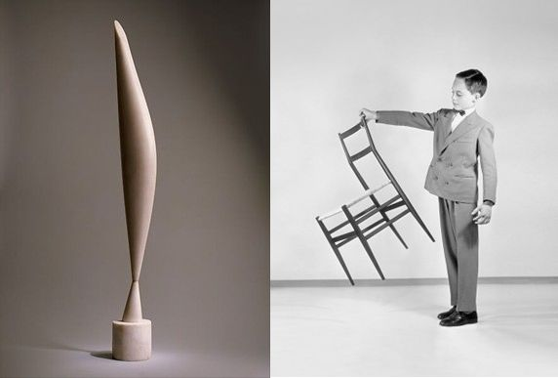
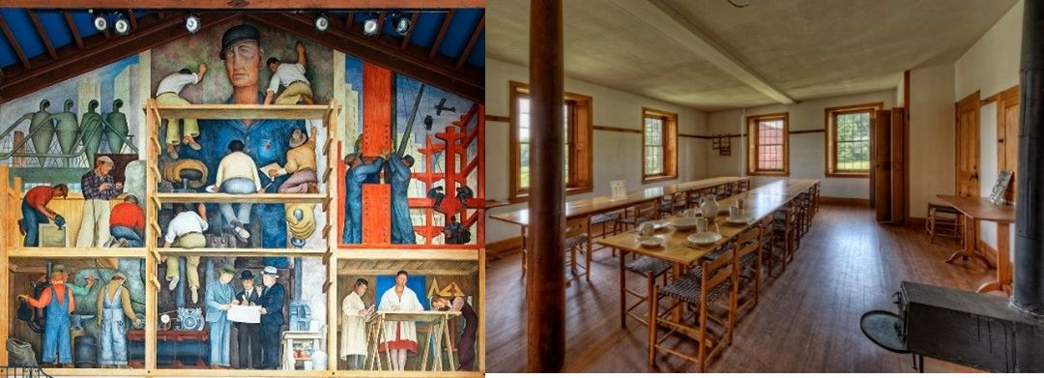
A comparison between artistic and design responses to the theme of lightness illustrates this difference. In Constantin Brâncuși’s Bird in Space (1923), lightness is expressed symbolically. The sculpture seems to lift upward, its smooth, streamlined form giving it a sense of weightlessness. Yet this lightness remains representational: the sculpture itself is actually heavy—carved from marble. By contrast, Gio Ponti’s Superleggera chair (1957) does not symbolize lightness; it incarnates it. Ponti’s aim was explicitly to create a chair “as light as possible”. The triangular-section ash wood legs maximize strength while minimizing material; the frame weighs only 1.7 kilograms; the structure is engineered so that lightness becomes a real property of the chair.
But the above comparison may also create a misunderstanding of my view: one might assume that a design practice must always seek to incarnate a theme within the designed object itself. This, however, is not my position. In my account, a theme may be incarnated either in the object itself or in its users. Often, a designed object serves as a medium through which a theme is realized in individuals or groups. The theme of collectivism makes this clear. In Diego Rivera’s mural The Making of a Fresco Showing the Building of a City (1931), collectivism is represented visually through coordinated workers and shared labor. The theme remains symbolic. By contrast, the Shaker Table used in Shaker communities did not depict collectivism; it enabled Shaker communities to live in a collectivist manner. Their extended surfaces, shared benches, and uniform proportions structured the conditions for collective meals and synchronized routines. The designed object becomes a means through which the theme is enacted in living people.
Figure 1 Bird in Space & Superleggera chair
Figure 2 The Making of a Fresco Showing the Building of a City & The Shaker Table

A Statement of My Work
If we accept this account of design and expressive art, it follows that a creatice practice can be both expressive and design-oriented, and a single work can be both a designed object and an artwork. This is because representation and incarnation are not logically mutually exclusive: a work that represents a theme can also serve as a medium through which the theme (or a different theme) is incarnated. My own work exemplifies this intersection of expressive art and design. On one hand, many of my projects contain expressive elements that operate through representation. On the other hand, these projects are also conceived as an endeavor to participate in, and to recover, the historical lineage of design practice as incarnation. Across different projects, the themes I explore vary, but the underlying method remains consistent. Each object begins with one or more concepts and then takes one of two approaches: it may represent a theme, or it may incarnate the theme by making it real in the object or in its users. In this way, my work moves between expressive art and design, sometimes operating through representation, sometimes through incarnation.
The next chapter presents several of my works in detail. While my practice lies at the intersection of expressive art and design, the narrative will emphasize how themes are incarnated rather than merely represented. I will also address specific problems encountered in the design or fabrication process, if they have not been discussed in my MA thesis. By analyzing how themes such as consolation, solemnity, continuity and compound vision are made real in objects or in their use, I aim to demonstrate how design as incarnation operates in practice. Through this narrative, the concept of design practice as incarnation moves from a historical and theoretical framework to a concrete design practice.

CASE STUDIES IN INCARNATION

Embrace Chair: Consolation
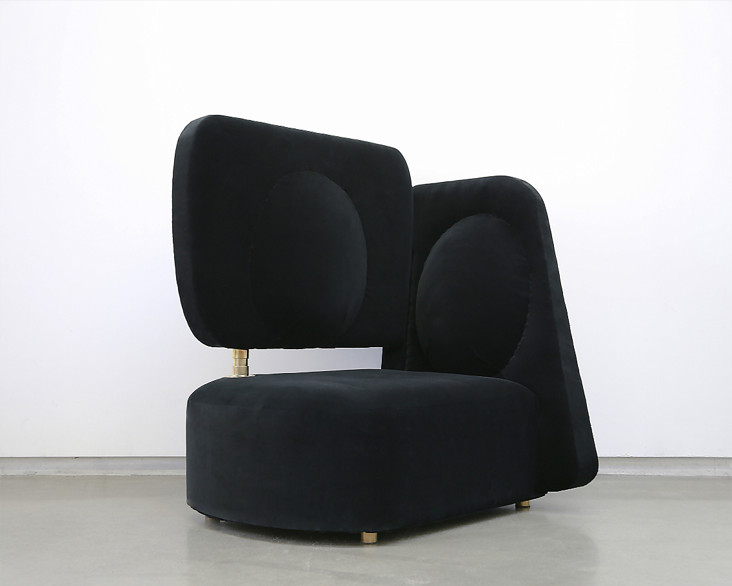
Embrace Chair was created in response to the sudden passing of a mother. The chair engages two distinct but related themes. On the representational level, it conveys the contour of a mother’s body and the emotional weight of grief. The extensive use of black establishes a visual language of loss and mourning. On the level of incarnation, the chair is conceived to incarnate consolation in its use. Its soft materials and embracing form are designed so that consolation becomes a condition enacted in the sitter’s bodily experience. In this way, the chair is not only an object that shows grief but also a medium through which its users are consoled.
Figure 3 Perspective View of Embrace Chair
The first aspect that contributes to the incarnation of consolation is the chair’s tactile softness—foam covered with pure velvet. Embrace Chair invites the sitter to sink into its surface. This sensation of being held produces relief and ease, allowing the body to relax and feel supported. The second aspect is the chair’s embracing geometry. Its curved frame gathers around the sitter, creating the sensation of being held. Sitting thus becomes an act of comfort rather than simple use.
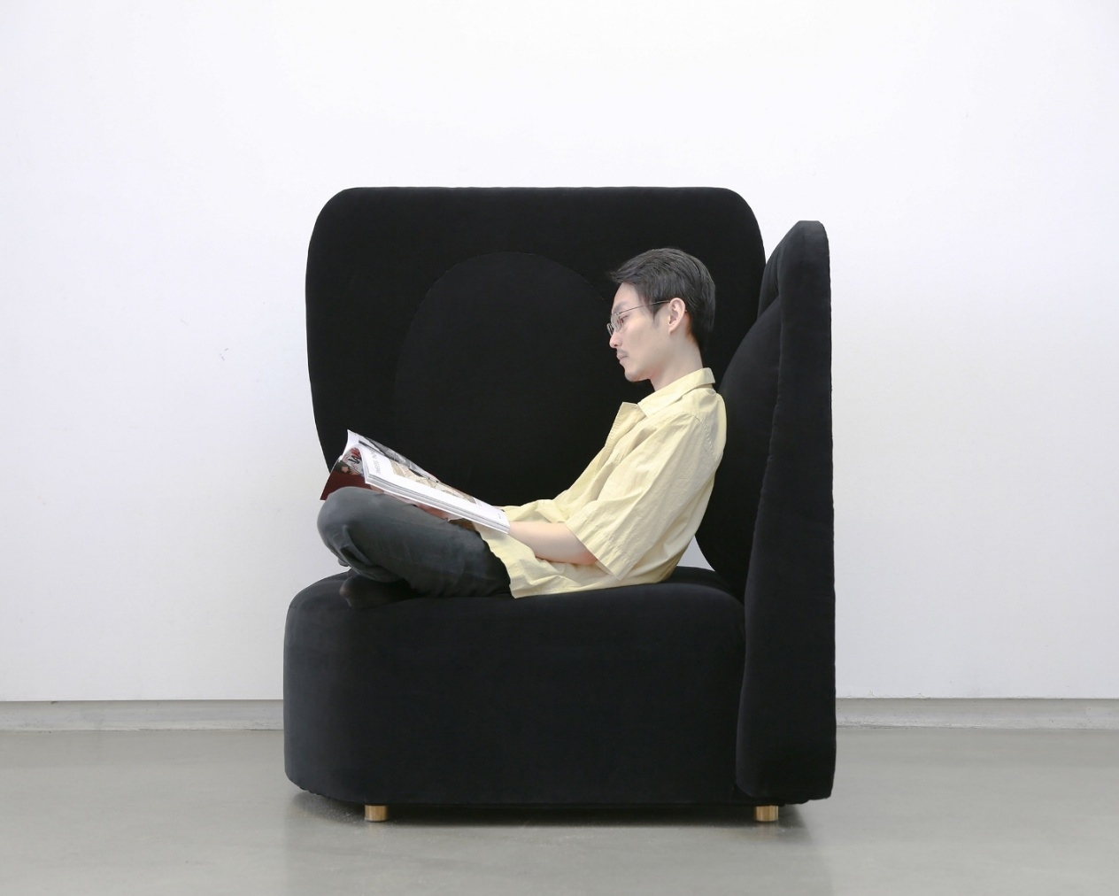
In sum, Embrace Chair conveys grief and maternal presence through its expressive form, while at the same time incarnates consolation through softness and enclosure. What it represents visually is loss, but it leaves its users consoled.
Figure 4 Front View of The Embrace Chair

Chair of Solemnity: A Solemn Way of Living
Chair of Solemnity takes solemnity as its central theme and engages it on two levels. On the one hand, the chair represents solemnity through its form and decor: the tall, architectural back and the continuous, disciplined pattern that runs through the piece establish a visual language of verticality and order. On the other hand, the chair is conceived to incarnate solemnity in its users. It is designed so that solemnity becomes a condition realized in the sitter’s comportment. In this way, the chair is not only an object that shows solemnity but a medium through which a solemn way of living can be practiced.
Figure 5 A Rendered Lifestyle Image
The first aspect that contributes to the incarnation of solemnity is the chair’s unusually tall, straight, and rigid back. It prevents the sitter from sinking or reclining into a relaxed position. To remain seated, the body is guided to align with the vertical axis established by the back. Sitting upright is not merely a physical matter—it produces a calm, attentive posture, and this bodily discipline helps transform solemnity into something real rather than simply represented.
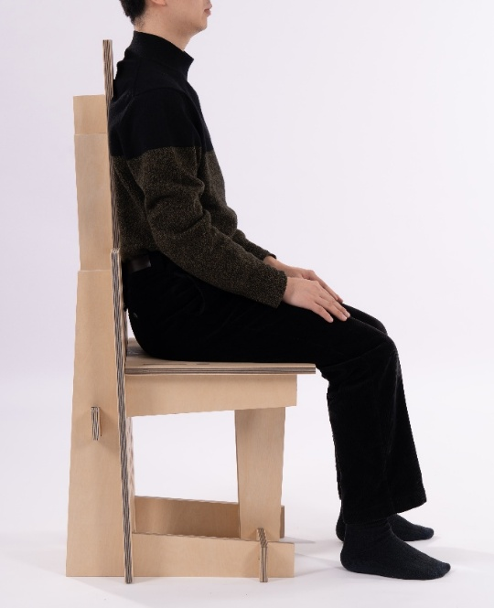
The second aspect concerns how the chair positions the sitter in space. The structure of the chair is derived from the easel: a device that holds and presents something to be seen. Translated into a chair, the easel structure subtly redefines the status of the sitter. One is not simply supported but held up and, in a sense, presented. The experience of being framed by an easel-like structure produces an awareness of one’s own presence, as if one were momentarily the subject of display. This self-awareness encourages the sitter to adopt a more deliberate and dignified posture. In this way, solemnity emerges as a mode of self-presentation shaped and sustained by the chair itself.
Figure 6 Side View of Chair of Solemnity
To sum up, Chair of Solemnity not only gives clear visual language of order but also shapes solemn human beings. Solemnity is not only shown in the object’s design; it is also lived through the ways of sitting and presenting oneself.

String Chair: Linear Continuity
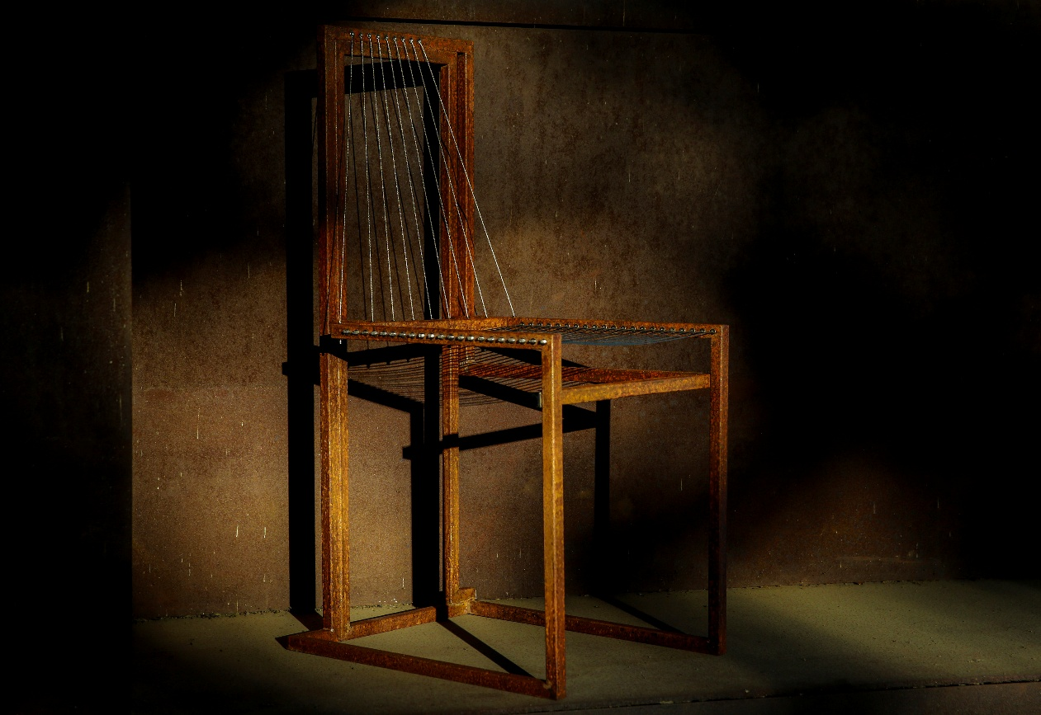
String Chair has a strong artistic presence. Its tight wire ropes and rust-red frame suggest the elegance of a violin while also recalling the vast suspension of the Golden Gate Bridge. Beyond these expressive associations, however, the chair is designed around a theme to be incarnated—Linear Continuity. My intention was to design a chair whose frame is made from continuous linear steel tubing, changing direction only through 90-degree turns, and to extend the linear concept to every other part of the chair. The chair’s final form—an angular steel frame paired with parallel lines—emerges directly from this pursuit of linear continuity.
Figure 7 The Linear Structure of String Chair in the Sunset
This commitment to Linear Continuity cannot be reduced to an attempt to simplify the making process. While it is true that the 90-degree joints standardize most welds into the repeated task of joining two tubes at a right angle, the commitment also complicates fabrication in other ways. For example, it introduces small parts that are otherwise unnecessary in order to maintain continuity, and it brings up the problem of how to join steel tubing without welding, as discussed in the next section. For this reason, it is linear continuity—rather than fabrication simplification—that is incarnated in the chair.

Joining Steel Tubing without Welding
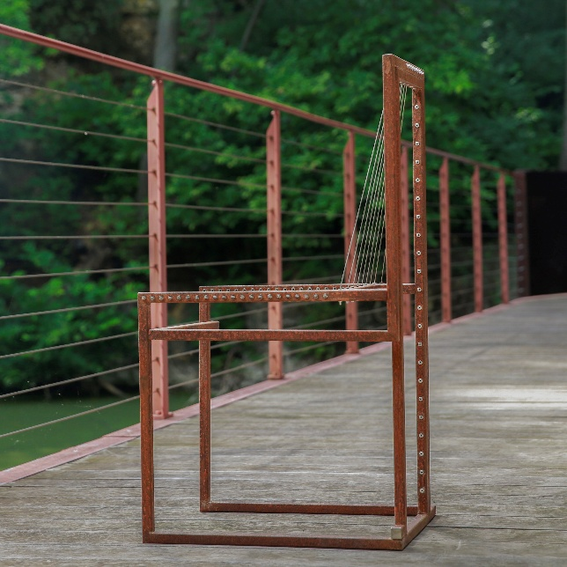
The commitment to Linear Continuity led to a frame design that uses two steel tubes running side by side. To make the structure secure, I needed to join the two tubes without welding—a weld would leave a raised bead that interrupts the straight profile of the tube and breaks the linear structure. To avoid this, the connection had to be mechanical rather than fused. The presence of this problem itself shows how strongly the design is committed to the theme of Linear Continuity.
Figure 8 Aluminum Rivets Used to Join Steel Tubes Without Welding
I eventually solved this problem by fastening the two tubes with a row of pop rivets. The rivets hold the tubes securely while keeping the profile uninterrupted. This method preserves the linear character of the frame and keeps the joining process simple.

Joining Wire Ropes to Steel Tubing
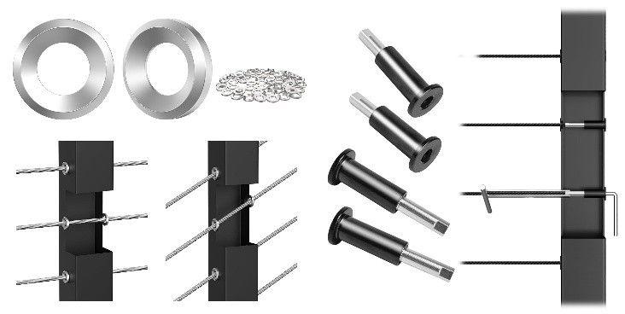
I chose wire rope as the secondary material for this chair because its neat, precise character fits well with the linear steel frame. When deciding how to connect the wire rope to the tubing, I investigated the way wire rope is typically attached to railing posts in architectural applications. In those systems, the rope passes through a post with a small metal or polymer sleeve separating the two materials to prevent abrasion, and a tensioner at the end tightens the rope.
Figure 9 Railing Posts Hardware
However, railing-post hardware is designed for much larger tubes and thicker wire rope, so it was difficult to find components that matched the dimensions of my materials. After searching widely, I found a stainless-steel body-jewelry component that happened to fit both the tube diameter and the wire rope perfectly, allowing it to function as the sleeve. The wire rope passes through the tube, and its ends are tightened and secured with aluminum crimps.
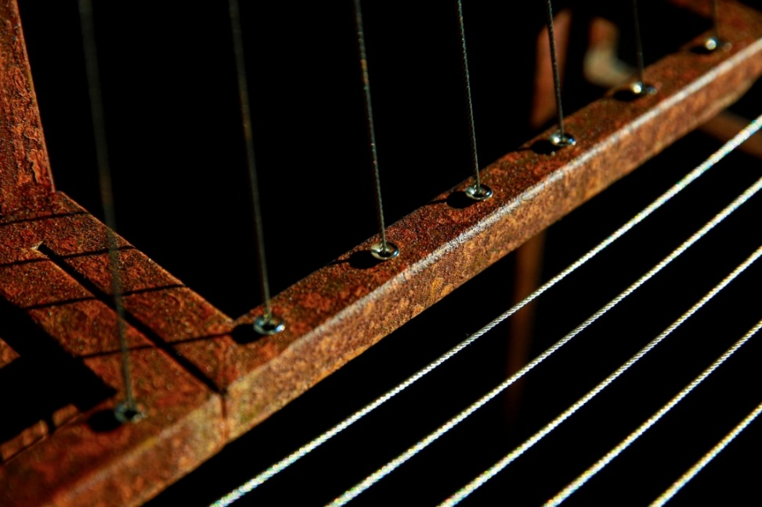
Figure 10 Detail of the Stringing Mechanism

PolyEye Divider: Compound Vision and Modularization
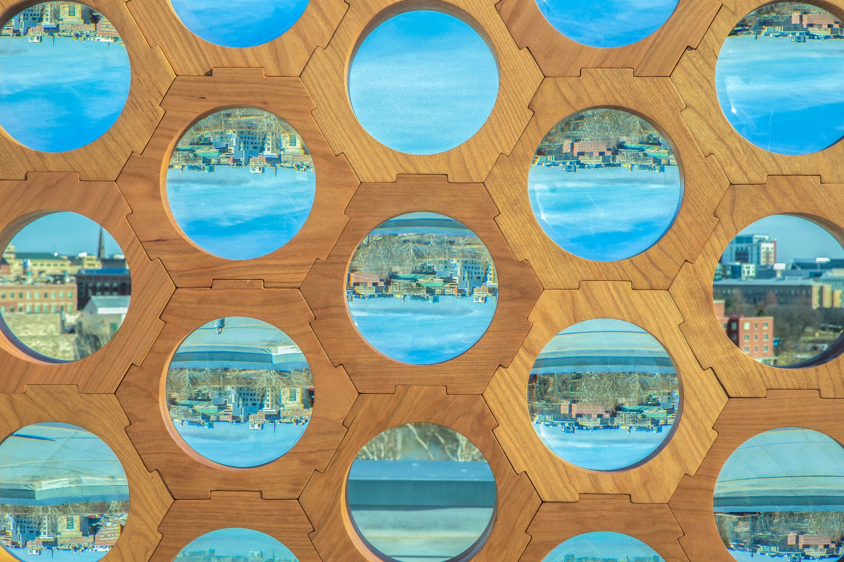
PolyEye Divider engages with the theme of compound vision and modularization. It attempts to bring the multi-faceted way of seeing found in insect eyes into human perception through a modular structure. The piece creates a fragmented yet collective visual field that reshapes how space is experienced. In this way, the work incarnates the theme of compound vision on a personal scale, turning an abstract concept into something experienced by individuals. Its hexagonal geometry evokes the image of a beehive or an insect’s compound eye, but the form was also intentionally chosen to modularize the divider for fabrication and transport. Breaking the whole into repeatable units allowed the piece to be fabricated in a streamlined manner and assembled or disassembled efficiently.
Figure 11 Compound Vision Achieved by PolyEye Divider

From Jewelry to Architecture: Scaling and Modularization
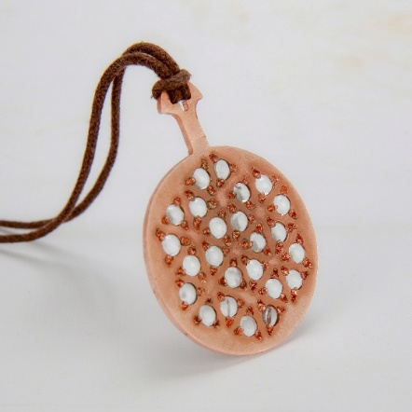
The theme of compound vision was first explored through the design of a jewelry monocle. This concept was later reimagined on an architectural scale as a space divider. However, the transformation from jewelry to space divider was not a matter of simple enlargement; rather, it was an iterative process to address the practical challenges of transportation.
Figure 12 Compound Eye Monocle

The space divider began as a large‑scale reinterpretation of a jewelry monocle—a large circular copper plate with embedded lenses, mounted using hardware typically found in magnifier frames. However, this first proposal was set aside due to concerns about transportation feasibility. To resolve this issue, I chose to modularize the design, allowing the divider to be disassembled and packed more efficiently.
Figure 13 Magnifier Frame Hardware
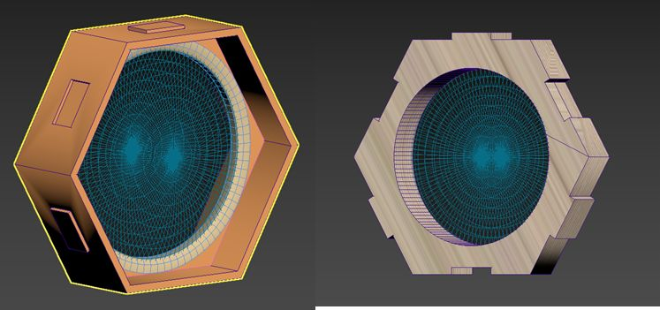
The first modular design, however, still relied on copper plates. Each lens was still intended to be embedded in a small copper plate, which would then be inserted into an album-like wooden frame constructed with mortises and tenons. While this approach was feasible to manufacture, it required a customized redesign of the above mentioned hardware and an extensive amount of hand woodwork. To simplify fabrication, the entire mechanism was reconsidered, resulting in the ultimate design: two pieces of CNC-routed cherrywood sandwiching a lens. Although this final version required the use of substantial cherrywood, it significantly streamlined the fabrication process.
Figure 14 The Comparison of Two Modular Designs

THE VISION: RETURNING TO PLURALISTIC INCARNATION
The future of design need not remain bound to the narrow imperatives of commerce. History reminds us that design has always been more than utility—it has served as a site of reform, critique, speculation, and imagination. To construe design practice as incarnation is to call for a renewed plurality of themes that can animate designers’ work. In such a future, design would not simply produce objects for markets but enable humanistic practices that broaden our sense of possibility. This vision is not nostalgic but generative: by recovering the richness of design’s past, we can imagine a field that embraces multiplicity, where each work incarnates a distinct horizon of thought. Design, then, becomes a medium through which society rehearses alternative futures—plural, open, and deeply human.

REFERENCES
Dunne, A., & Raby, F. (2013). Speculative everything: Design, fiction, and social dreaming. MIT Press.
Gropius, W. (1919). Bauhaus Manifesto and Program. In U. Conrads (Ed.), Programs and Manifestoes on 20th-Century Architecture (pp. 49–53). Cambridge, MA: MIT Press.
Hart Design Selection. (n.d.). Radical Design: Italian Anti-Design 1960–1975. Retrieved March 21, 2026, from https://hartdesignselection.com/en/radical-design-italian-anti-design-1960-1975/
Kiaer, C. (2005). Imagine no possessions: The socialist objects of Russian Constructivism. Cambridge, MA: MIT Press.
Pevsner, N. (1960). Pioneers of modern design: From William Morris to Walter Gropius (Rev. ed.). Harmondsworth: Penguin Books.
Sadler, S. (2005). Archigram: Architecture without Architecture. Cambridge, MA: MIT Press.
Sparke, P. (1986). An introduction to design and culture: 1900 to the present. London: Routledge.
Neuhart, J., Neuhart, M., & Eames, R. (1989). Eames design: The work of the office of Charles and Ray Eames. New York: Harry N. Abrams.
Schildt, G. (1998). Alvar Aalto: The complete catalogue of architecture, design and art. New York: Rizzoli.

