Name: Siyun Xue
Dissertation Title: In Defense of the Non‑formalized Design Tradition:
A Case Study of Circulation Design Through the Lens of Gestalt Dynamics
Main Theses:
- The design community’s long‑standing unease about design “intuition” is best addressed by making explicit the real capacities that designers rely on.
- Built environments shape movement patterns in the same way initial conditions shape the evolution of holistic dynamical systems.
- Circulation design practice is best understood as an emulation–observation model grounded in the capacity of phenomenal emulation.
- Design pedagogy should cultivate the capacity for phenomenal emulation rather than teach rule‑based formal procedures.

Table of Content and Summary
1. Introduction
The introduction frames the dissertation’s central problem: the design community’s longstanding unease with designers’ reliance on an opaque intuitive capacity, and it proposes circulation design as a case study for clarifying its underlying capacity through a dynamical, Gestalt‑informed framework.
1.1. The Design Methods Movement and Its Motivating Concern
Explains how the Design Methods Movement attempted to replace intuition with systematic methods, ultimately failed, and left its motivating concern unresolved.
1.2. The Domain of Inquiry: Circulation Design
Defines circulation design as the dissertation’s domain, explains its meaning as the design of collective‑level movement patterns, and gives design cases.
1.3. Why Circulation Design? Two Motivating Considerations
Justifies focusing on circulation design by showing that its means and ends are unusually clear and that it occupies a central position in environmental design debates that originally fueled the Design Methods Movement.
1.4. A Working Hypothesis
Proposes that circulation design operates like the study of holistic dynamical systems, where designers learn through constructing and observing environmental setups.

1.5. Plan of the Dissertation
Outlines the dissertation’s argumentative sequence: establishing a Gestalt-theoretical basis for the analogy, interpreting circulation design practice as an experiment–observation model, and finally characterizing the capacity that enables such practice.
2. The Gestalt Dynamical Framework
This chapter introduces the Gestalt theoretical framework—its critique of atomism, its dynamical account of neural organization, and its conception of the phenomenal field—to supply the conceptual resources needed for the dissertation’s central analogy.
2.1. The Problem of Perceptual Organization
Critiques mechanistic and associationist theories for failing to explain holistic perceptual organization.
2.2. The Dynamical Approach
Introduces Köhler’s view that perceptual organization arises from the dynamic self‑distribution of neural processes rather than from fixed pathways or accumulated associations.
2.3. The Principle of Isomorphism
Explains the structural correspondence between phenomenal organization and the dynamical organization of underlying physiological processes.
2.4. Constituents of the Phenomenal Field
Describes the phenomenal environment and the phenomenal ego as two closely related components of the phenomenal field—two experiential manifestations of relatively distinct regions within a single dynamically organized neural field.
3. Environment and Movement: A Phenomenal‑Dynamical Relation
This chapter argues that architects design phenomenal environments (rather than physical environments), that movement patterns are best understood as regularities in the evolution of the phenomenal field, and concludes that a built environment shapes a movement pattern in the same way that the initial conditions of a holistic dynamical system constrain its subsequent evolution.
3.1. The Built Environment as the Phenomenal Environment
Argues that architectural design concerns the phenomenal environment, not the physical environment as such.
3.2. Movement Patterns as Phenomenal Evolution
Reinterprets movement patterns as collective-level regularities in the evolution of the phenomenal field rather than as physical trajectories through space.
3.3. The Temporal Extension of Movement Patterns
Explains how long‑term movement patterns arise from a sequence of short‑term phenomenal reorganizations continuously perturbed by changing environmental conditions.
4. A Dynamical Account of Circulation Design in Practice
This chapter interprets circulation design practice as a form of environmental emulation that enables designers to study how the phenomenal field would evolve under different configurations through experiment-like observation.
4.1. Circulation Design: Theory and Practice
Contrasts quantitative research models with the representational tools and iterative strategies circulation designers actually use.
4.2. Interpreting Practice Through Environmental Emulation
Shows how the emulation–observation model makes sense of real circulation design cases by interpreting designers’ sketches, floor plans, models, and simulations as tools for constructing experimental setups
4.3. The Capacity for Phenomenal Emulation
Identifies the core design capacity as the ability to emulate both the phenomenal environment and the phenomenal ego with sufficient precision to anticipate how the phenomenal field would evolve.
5. Implications on Design Pedagogy
Discusses how clarifying the capacity of phenomenal emulation reshapes design pedagogy by shifting instruction away from rule-based methods toward cultivating students’ ability to emulate and anticipate the evolution of the phenomenal field. What must be taught, in other words, is not a rule-based method but an ability to construct, inhabit, and iteratively refine emulated environments and a mode of phenomenal reasoning—an ability to sense how a configuration will reorganize over time.

- Introduction
The practice of design is, by its very nature, the pursuit of design works with intended features. What, then, is the kind of knowledge or ability that makes this pursuit possible? A widespread view holds that “good designers simply have a knack for coming up with something that ‘does the trick,’ just as good artists have a knack for creating beautiful or intriguing artworks” (Parsons, 33). Good designers, in other words, are thought to rely on a mysterious power to arrive at intended designs, whether this power is called “intuition” or something else.
  - The Design Methods Movement and Its Motivating Concern
This widespread view—that designers rely on a mysterious power—concerned many design theorists because this power is regarded as inaccessible, even to designers themselves, and therefore unreliable. This concern is further intensified by the fact that certain fields of design, such as urban planning and high-stakes engineering design, can have significant social and financial consequences. (Parsons 33; Jay 14; Jones 1992, 45; Simon 112).
Due to this concern, a group of designers and design theorists—whose leading figures include Bruce Archer, John Chris Jones, Christopher Alexander, and Horst Rittel—launched the “Design Methods” movement in 1962, seeking to introduce accessible and systematic methods from other fields (especially science) into design. A series of conferences on design methods were held in the 1960s and 70s and many design methodology books were also published in this period (Langrish, 3-4).
The end of Movement, however, is disappointing. Christopher Alexander, one of the leading figures of the movement, in the new preface to his book Notes on the Synthesis of Form completely denied the idea that design methods can be a subject of study separate from design practice:
Indeed, since the book was published, a whole academic field has grown up around the idea of “design methods” and I have been hailed as one of the leading exponents of these so-called design methods. I am very sorry that this has happened, and want to state, publicly, that I reject the whole idea of design methods as a subject of study, since I think it is absurd to separate the study of designing from the practice of design. (Alexander, Preface)
Another leading figure, John Chris Jones, experienced the most drastic change. Jones published Design Methods in 1970, which is the most comprehensive review of different new design methods proposed in 1960s, and from 1971-73 he served as the Chair of the Design Research Society, the organization committed to design method research. However, in a poetry collection first published in 1984, he articulated his opposition to the Design Methods movement: “In the seventies I reacted against design methods. I dislike the machine language the behaviourism, the continual attempt to fix the whole of life into a logical framework.” (Jones 1991, 22) Jones resigned from his university position in 1974 and started doing poems and experimental forms of writing.
The movement ended in the 1980s, and to this day, no systematic approach to design has been universally accepted by the design community. Judged by its outcomes, the movement can be considered a total failure. However, the concern that sparked it has not disappeared: if designers have been relying on a capacity whose nature remains entirely unclear to us, then there is a need to replace that capacity with accessible and systematic design methods. Although this concern is rarely mentioned by contemporary design theorists, it continues to subtly trouble the design community, which is reflected in the fact that most design schools still teach flexible problem-solving frameworks—such as the analysis-synthesis model—in introductory design classes.
However, instead of suggesting a new design method, there is another way to address the concern underlying the Design Methods movement. Designers and design theorists troubled by the appeal to an unknown capacity in design are in a position similar to that of sailors in twelfth-century Europe who rejected the use of the compass and regarded it as demonic because they did not understand magnetism. Their distrust of this unknown capacity did not stem from any failure of the capacity itself, but from ignorance of its nature. Hence, rather than proposing yet another systematic design method, the concern can be addressed by articulating—through philosophical resources—the capacity that designers have long been relying upon. This dissertation is an attempt to address the concern through this approach.
  - The Domain of Inquiry: Circulation Design
Like other specialized forms of human activity with a long history, design has evolved into various branches with distinct purposes, and it is doubtful that all of these branches rely on the same capacity or set of capacities. For example, engineering designers mainly address engineering problems and therefore must possess strong engineering problem-solving capacities. In contrast, graphic design focuses on the effective transmission of information through visual form, which requires graphic designers to possess strong visual literacy and sensitivity. To ensure that my project remains manageable and to avoid the risk of overgeneralization, the research must be confined to one area of design, or even one specific aspect within that area.
The focus of this dissertation will be circulation design or circulation planning (as elaborated below), an important component of architecture. Drawing on its biological origin—where the term denotes the movement of fluids within an organism—“circulation” in architecture came to describe people’s movement pattern through a space. (Clemente and Isidori, 2019) The word “pattern” refers to the collective-level regularities, rather than regularities about an individual. Accordingly, circulation design refers to the use of architectural elements to produce an intended people’s movement pattern through a built environment.
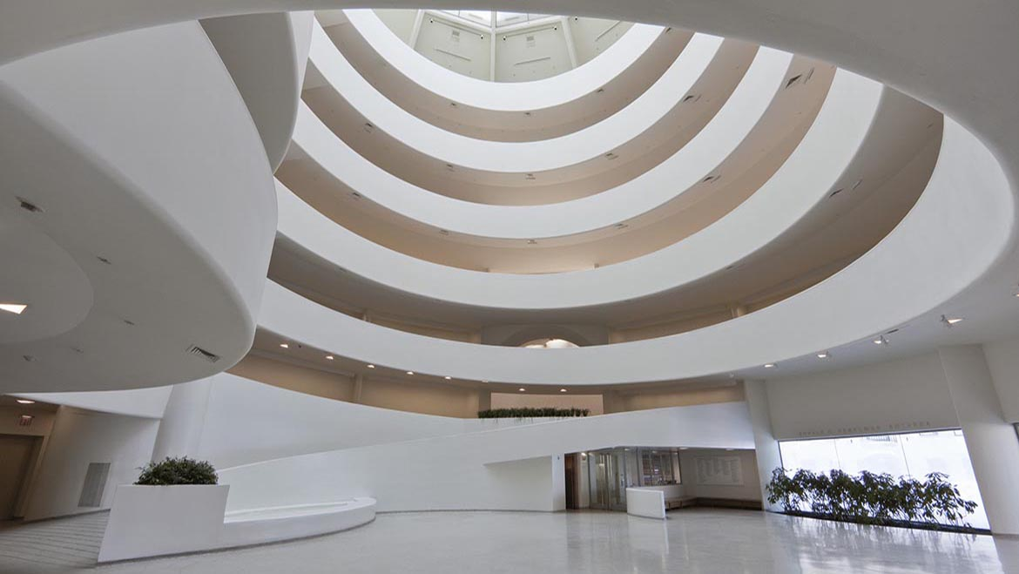
A familiar example of circulation design in practice is the organization of movement in museums, in which the spatial arrangement of galleries directs visitors’ movement and frames their experience of the collection. Another example can be found in hillside parks, where the topography, path gradients, and placement of overlooks naturally guide how visitors ascend, descend, pause, and traverse the landscape, thereby structuring their movement without relying on graphic cues or signage.
Figure 1 Guggenheim Museum by Frank Lloyd Wright, a classic example of museum circulation design.
  - Why Circulation Design? Two Motivating Considerations
There are two considerations that motivate this focus. First, the means and end of circulation design are relatively clearer than those of many other areas of design, providing a workable point of departure for the present research. The only contentious issue regarding the means and end of circulation design concerns which architectural elements properly count as its means. Traditionally, spaces within the built environment were understood to fall into two categories: transitional spaces (such as stairs, corridors, ramps), which were considered responsible for people’s movement pattern, and destination spaces (such as offices, galleries, or living rooms), which were not. Under this view, circulation design was thought to be achieved solely through the planning of transitional spaces. However, a more recent and widely accepted perspective in architectural studies challenges this binary distinction. As scholars have noted, “there are numerous spaces that, though intended for circulation, invite one to linger in, and conversely, a degree of movement takes place in every space that people stay in.” (Lederer 15, 2013) In other words, all spaces within a built environment influence people’s movement pattern to some extent, and the means of circulation design cannot be limited to the treatment of conventionally transitional spaces. Instead, it must take into account the movement-shaping capacities of all spaces. In this dissertation, I will also adopt this latter view.
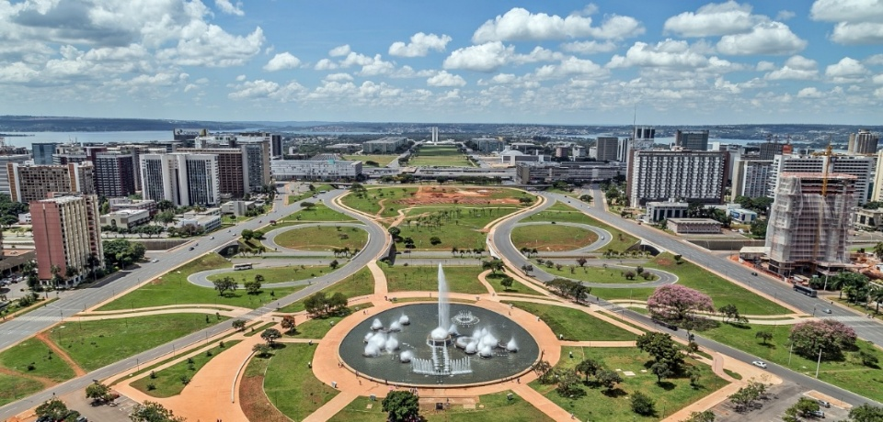
The second consideration that motivates my focus on circulation design is that it constitutes a central component of environmental design, whose methodological debates directly prompted the emergence of the Design Methods Movement. The phrase “environmental design” is, in its literal sense, an umbrella term referring to the design of man-made spaces across multiple scales, including urban planning, architecture, interior design, and landscape design. Historically, however, the term carried an additional social dimension: it referred not only to the shaping of environments but also to the pursuit of particular forms of social organization through that shaping. (Bill, 2014) A well-known example of environmental design is the design of Brasília, Brazil’s modern capital city. The spatial structure of the new capital—its monumental axis, superquadra housing units, and strict functional zoning—was conceived as a means of producing a modern, orderly, and rational social order. Circulation design is central to environmental design, insofar as patterns of movement are generative of social relations—by creating a pattern of movement, it also creates patterns of encounter and avoidance, thereby shaping the very forms of social interaction that emerge within a built environment. In addition, there had already been various attempts to systematize circulation design, drawing on quantitative approaches such as space-syntax analysis (Hillier, 1984) and visibility-based studies (Benedikt, 1979) to account for how spatial configuration shapes movement patterns. By focusing on circulation, rather than on other areas of design that were only marginally addressed by participants in the Design Method Movement, this dissertation engages directly with the Movement’s core concerns
Figure 2 Brasília, a planned city by Lúcio Costa, Oscar Niemeyer and Joaquim Cardozo
  - A Working Hypothesis
In the study of holistic dynamical systems—such as those examined in fluid mechanics or meteorology—scientists do not acquire knowledge of system evolution by attempting to predict the trajectories of all constituent elements through force analysis. Instead, they investigate system behavior by constructing experimental setups. Through adjustments of these setups and observing how the system evolves, researchers learn how the system reorganizes itself over time under different initial conditions. What emerges from this practice is a form of knowledge grounded not in rule-based prediction, but in observing how different configurations give rise to different developmental trajectories. The system’s evolution becomes predictable only after scientists have experimentally explored how it behaves under a range of different setups.
Now, if the way a built environment shapes a movement pattern is analogous or even identical to the way a holistic system‘s initial condition limits its subsequent evolution, then the movement pattern within a built environment can be researched in the same way scientists research the evolution of a dynamic system. Just as scientists learn how a system develops by varying initial conditions, circulation designers can also gain insight into movement patterns by constructing different environments and observing their effects.
This idea offers a clue to understanding circulation designers’ actual practice, which relies not on quantitative models but on tools such as floor plans, physical and digital models, and virtual-reality simulations. Because circulation designers, unlike scientists, cannot construct full-scale environments solely for experimental purposes, these tools can be construed as means for emulating an environment in which an experiment can take place. Their analyses of movement patterns can thus be understood as the results of observing how the emulated environment evolves.
What this emulation consists in, however, and how these tools contribute to it, must be examined later. If this interpretation of circulation design practice is correct, then the essential power underlying circulation design lies in the capacity to emulate environmental conditions with sufficient precision for experimentation—a capacity whose nature will remain unclear until the notion of emulation itself is clarified.
  - Plan of the Dissertation
This dissertation seeks to clarify the capacity that has long guided circulation designers’ work. The first step, however, is to explain how the analogy or identity between environment–movement relations and system-setup–system-evolution relations can be made intelligible. To do so, I draw on theoretical resources from the Gestalt tradition, particularly their claim that the physiological processes underlying perception are dynamically distributed across the neural field. Once this analogy or identity is established, I will then be in a position to argue that circulation designers’ actual practices can be interpreted as an experiment–observation model for studying the evolution of a dynamical system. After refining this interpretation, I will return to characterizing the capacity at issue.
- The Gestalt Tradition
The Gestalt movement emerged in the early twentieth century as a systematic challenge to atomistic and associationist accounts of mind—approaches that understood mental life as discrete sensory elements and the associative links between them. Initiated by Max Wertheimer and developed further by Wolfgang Köhler and Kurt Koffka, the school argued that psychological phenomena exhibit holistic structures that cannot be derived from the summation of discrete sensory elements. Their central claim was that perception is intrinsically organized: what appears in experience is not a mosaic of independent sensations but a holistic field. This shift in explanatory focus—from elements to organized wholes—was articulated across a series of works, including Wertheimer’s early papers on perceptual organization, Köhler’s Gestalt Psychology (1929), and Koffka’s Principles of Gestalt Psychology (1935).
Köhler’s Gestalt Psychology and Koffka’s Principles of Gestalt Psychology (1935) are the two most comprehensive and systematic articulations of the Gestalt tradition. The two books share a common problem consciousness—accounting for the emergence of perceptual and behavioral order—and proceed from many of the same foundational assumptions. The main difference between the two books lies in their respective treatments of behavior: Koffka’s later chapters develop a more elaborate behavioral theory, drawing in part on Köhler’s later papers. In general, Köhler’s book offers a clearer and more concise articulation of the core Gestalt commitments, whereas Koffka’s text provides a more systematic and expansive exploration of the broader theoretical landscape. Given the present aim of providing a concise overview of Gestalt tradition, Köhler’s book will serve as the primary point of reference, with Koffka’s more expansive account consulted where helpful.
  - The Problem of Perceptual Organization
In Gestalt Psychology, Köhler directs his critique against two influential explanatory frameworks that dominated early twentieth-century accounts of perceptual organization: machine theory and empiricist associationism. Although they differ in their assumptions about the origin of sensory order, both approaches share the conviction that perceptual organization can be reduced to the arrangement and combination of local sensory elements. Machine theory holds that the structure of the nervous system contains pre-established, innate pathways that rigidly determine the form of perceptual experience; the stability of shapes, symmetries, and other orderly features of vision is attributed to these fixed anatomical arrangements. Empiricist theory, by contrast, rejects innate structure but preserves the mechanistic view that perceptual order arises from the learned linkage and accumulation of local sensory inputs: it proposes that perceptual order comes from associations we learn through experience, where repeated connections between local stimuli eventually build up into more complex perceptual patterns. In both cases, the explanation of perceptual order is located in external arrangements—whether inherited or learned—rather than in the intrinsic nature of the perceptual field.
Both frameworks, however, face difficulties once one turns to the actual phenomena of perception. Köhler argues that the inherited pathways cannot account for the striking flexibility, context-dependence, and holistic organization that characterize the sensory field. Many perceptual phenomena—such as the sudden reorganization of ambiguous figures, the influence of surrounding conditions on the appearance of form, or the persistence of constancy effects despite changes in stimulation—casts doubt on the it. The empiricist alternative fares no better than the machines theory: although it replaces innate pathways with acquired associations, it retains the assumption that perceptual structure must be built up from local elements. For Köhler, this merely substitutes one kind of external arrangement for another and leaves unexplained how global properties emerge, why certain organizations appear immediately rather than gradually, and why the perceptual field behaves as a coherent whole rather than as a mosaic of independent parts. (See, Köhler, Chapter IV)
A clear example discussed by Köhler is the phenomenon of color contrast, which illustrates the same difficulty for both theories. He notes that a region of the visual field may appear to have one quality when surrounded by a dark area and a quite different quality when placed within a lighter surround, even though the local stimulation at that region remains unchanged. The appearance of the region shifts solely because the surrounding field has changed. This simple case shows that perceptual qualities cannot be derived from the local stimulus itself or from any fixed or learned linkage among its elements; instead, the perceived character of a part depends on the broader conditions of the field in which it is embedded. (Köhler, 125-126)
  - The Dynamical Approach
Instead of treating perceptual organization as the product of fixed anatomical pathways or accumulated associative linkages, Köhler proposes that the perceptual field exhibits orders that can be explained only by the dynamical self-distribution of physiological processes (i.e., neural events). By “dynamical self-distribution,” he refers to phenomena such as the way a disturbance created by a thrown stone spreads across the surface of water, or the way the thermal energy in a cup of hot water redistributes when a drop of cold water falls into it. In accounting for perceptual organization, Köhler assumes that physiological processes in the brain are not transmitted in a point-to-point fashion, as contemporary neuroscience often depicts, but instead spread through the system in the manner of a disturbance propagating within a holistic medium, shaped by the interactions among its components:
Dynamical self-distribution is the third kind of functional concept which I propose to add to psychological theory, in addition to distribution enforced by inherited arrangements and order determined by acquired arrangements. More concretely and for the visual field, my assumption is that the order and distribution in this field is in each case the result of dynamical interaction. From this viewpoint the processes underlying the visual field in a state of rest represent the equilibrated distribution of sensory dynamics under actually given conditions. When not at rest, sensory dynamics will be in a state of developing dynamical distribution. (Köhler, 140)
We have the patterns of different chemical reactions on the retina, as they are produced in each case by actual stimulation … If neurologists are correct when they assert that between the retina and the area striata of both hemispheres, conduction is a matter of isolated pathways, then the area striata will be a sort of “central retina,” in which the pattern of retinal stimulation is copied by a pattern of central processes. In this case dynamical distribution will begin here, depending upon the actual pattern of processes in the occipital lobes. (Köhler, 141)
According to this dynamical approach, external stimulation initiates a disturbance in the neural network (striate area) whose subsequent course is shaped by the network’s own physical constraints. A stimulus therefore produces a pattern of excitation and inhibition that spreads across the network and reorganizes itself until the system reach a state of equilibrium. It is this continuous dynamical process—rather than the initial stimulus pattern or any associative linkages—that determines the similarly dynamic organization of the perceptual field.
  - The Principle of Isomorphism
Within this framework, Köhler introduces the principle of isomorphism to articulate the relation between the organization of the perceptual field and that of the underlying physiological processes: for each spatiotemporal relation or quality in the perceptual field there must be a corresponding dynamical relation or quality in physiological processes. Köhler emphasizes that this correspondence does not imply a necessary identity between the relations or qualities at the two levels; it asserts only that relations and qualities in experience have counterparts in the dynamical organization of the underlying processes.
To use a case discussed by Köhler as an example: when one point is seen between two others, the relation of “between” is experienced as immediately as any sensory quality, yet nothing in the local stimulation specifies this relational fact. Köhler therefore holds that the phenomenal relation of “between” must correspond to a dynamical relation within the physiological processes—for example, a case in which one process mediates the interaction between two others, even though this mediating role is not itself a spatial “between” relation. (Köhler, 61-66, 225-226)
  - Constituents of the Phenomenal Field
Another point that must be noted for the following discussion is how the Gestalt school conceives the constitution of the phenomenal field. For Gestalt theorists, The phenomenal field is the domain of conscious experience, distinct from the physical environment and from the biological organism. Although their analyses focus primarily on the visual field, they take the phenomenal field in principle to be multisensory in scope.
In both Köhler and Koffka’s books, the phenomenal field, as a result of the distribution of underlying physiological processes, comprises two closely related constituents—two components that are not independent domains but the experiential manifestation of two relatively distinct regions within a single underlying field of physiological processes. One is the phenomenal environment, the world as it appears within experience, including objects and their perceived behaviors. Köhler explicitly includes the phenomenal body within this environment: the experienced hands, legs, nose, and other bodily parts belong to the same phenomenal surroundings as external objects. Koffka later refers to this same domain as the behavioral environment, emphasizing that it is the phenomenal environment—not the physical one—that accounts for most of our actions. (Köhler, 141; Koffka, 40)
The other constituent is the phenomenal ego, the experienced complex of intentions and desires, and the center of orientation from which directions, distances, and perspectives are articulated. This phenomenal ego is not the anatomical organism but a structural point situated within the phenomenal environment. (Koffka, 39)

- How Does A Built Environment Shape a Movement Pattern?
The preceding chapter established the Gestalt-theoretical framework necessary for the following discussion on the relation between a build environment and people’s movement pattern in the environment. The value of Gestalt theory for our purposes lies in its account of the perceptual field as the outcome of a dynamically self‑organized neural network. This account provides the theoretical resources needed to make intelligible the central hypothesis introduced in Chapter I: that the way a built environment shapes a movement pattern is analogous or even identical to the way the initial conditions of a holistic system limit its subsequent evolution.
Now, if we can demonstrate that the built environment of architects’ concern is essentially a phenomenal environment, and that the so-called “movement pattern” of their concern is not regularity regarding physical paths in a physical environment, but essentially the regularity regarding the evolution of phenomenal field, then within the Gestalt framework the hypothesis is correct. It is because, according to the principle of isomorphism, a given phenomenal environment must be accompanied by a corresponding set of conditions in the underlying physiological processes. These conditions constrain the possible trajectories of neural events—their interaction and distribution—and thereby constrain how the phenomenal field will evolve.
  - The Built Environment as the Phenomenal Environment
Although the built environment—namely, the environment constructed and experienced by people—is realized through physical interventions in the physical world, it is, in essence, a phenomenal environment. In other words, to design an environment is not to design the physical world as such, but to design a phenomenal environment. Traditionally, architectural discourse has treated the built environment primarily as a visual field. Contemporary architectural practice, however, increasingly incorporates multisensory strategies: sound, temperature, texture, and smell are deliberately orchestrated to shape how a place is experienced. Given these developments, it is fair to say that the built environment of architects’ concern is, in contemporary practice, a multisensory phenomenal environment. (See Pallasmaa, 124-127)
  - Movement Pattern as the Evolution of the Phenomenal Field
A movement pattern should also not be understood simply as the pattern of paths people trace through physical space. In circulation design practice, designers routinely consider factors that exceed the geometry of paths: what a person sees at a given position, how long they are likely to pause, how their attention shifts, how their sense of enclosure or openness changes. These considerations belong not to the physical trajectory but to the phenomenal change. When these diverse considerations are taken together, it becomes clear that what circulation designers analyze is not the collective-level regularity of physical displacements but the collective-level regularity of phenomenal evolution. A movement pattern, in this sense, is a pattern in the evolution of the phenomenal field—some things draw closer, some areas fall out of view, boundaries shift, new vistas open, etc.
  - The Temporal Extension of Movement Patterns
Once the built environment is understood as the phenomenal environment and movement pattern as the pattern of the evolution of the phenomenal field, it becomes immediately intelligible within the Gestalt framework that the built environment shapes a movement pattern in the way an initial setup of a holistic system shapes a pattern of the evolution of the system.
One might object to my interpretation of a movement pattern as a pattern concerning how the phenomenal field evolves by pointing out that movement patterns in circulation design should always involve a long‑term process—sometimes extending across an entire walkthrough in a built environment. Now, if the evolution of the phenomenal field is driven solely by the self‑organization of the underlying physiological processes, such an evolution cannot persist over long stretches of time, for the physiological field would quickly settle into equilibrium. Hence, this short‑term phenomenal evolution leaves no basis for a long‑term movement pattern.
This concern rests on an implicit assumption that the phenomenal field evolves only once from a single initial condition. In practice, however, the physiological field is continually perturbed by new physical conditions as one moves through an environment. Each spatial episode—an exhibition highlight, a sudden opening into a new gallery, a shift in lighting, a change in acoustic texture—implies new stimuli that destabilize the underlying physiological field and initiate a new phase of reorganization. Metaphorically speaking, the underlying physiological field is “recharged” repeatedly to allow its evolution to continue unfolding. In this way, an long-term phenomenal field evolution is generated, not as the result of a single uninterrupted evolution but the concatenation of multiple short-range evolutions. A movement pattern, therefore, is the regularity about the cumulative trajectory.

- A Dynamical Account of Circulation Design in Practice
Once the relation between the built environment and the movement pattern is clarified—namely, that the built environment functions as a set of initial conditions and the movement pattern is the pattern of the following evolution—a possible model of circulation design becomes available. Now, designing a movement pattern can be achieved by shaping those initial phenomenal conditions and observing how the field would reorganize from them.
On this view, circulation design is not the derivation of movement from rules and formulas. It is an experiment–observation practice: the designer constructs an emulated environment, examines how the resulting phenomenal field would evolve, and adjusts the initial conditions until the intended trajectory pattern is reached. The design process thus becomes an exploration of how different initial phenomenal configurations constrain the field’s possible reorganizations.
  - Circulation Design: Theory and Practice
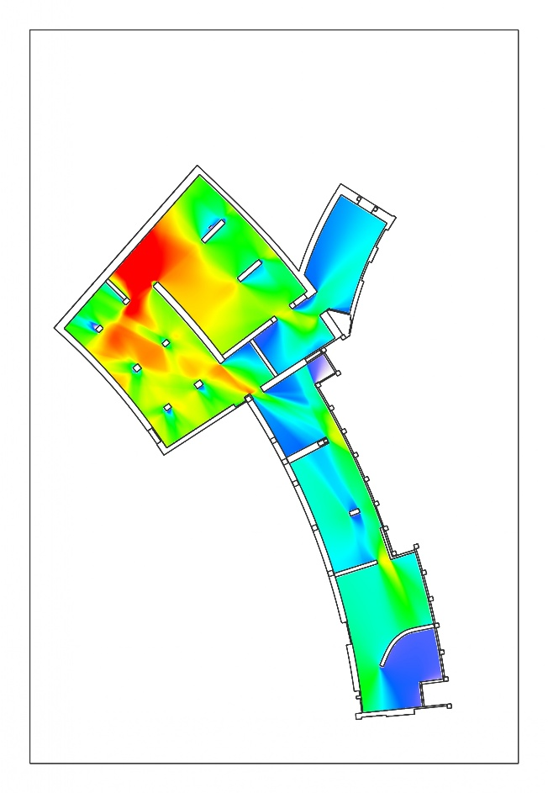
In contemporary architectural research, circulation design is often framed through quantitative and computational approaches that aim to formalize the relationship between spatial configuration and movement. Methods such as space syntax and visibility analysis treat circulation as a phenomenon that can be measured, modeled, and predicted. These techniques translate space into networks of nodes and connections, quantify visual fields, and simulate flows of agents to infer likely movement patterns. Within this theoretical framework, circulation design appears as a domain in which movement can be systematically derived from spatial geometry, and where design decisions can be justified through analytic metrics and predictive models.
Figure 3 Visibility analysis map of the Temporary Exhibition Gallery at Crystal Bridges.
In practice, however, circulation design unfolds through a very different set of tools. Designers typically begin by sketching circulation paths directly onto floor plans. As the project develops, they construct small physical models and digital models to help analyze movement patterns. In recent years, new representational techinologies, such as virtual reality, are also used to approximate how people navigate space.
All these tools help analyze how movement will unfold in the built environment, yet the reasoning that guides such analysis remains largely implicit. Designers draw on intuition and experience in ways that are difficult to formalize. Quantitative models, when used at all, serve only as supplementary checks rather than primary generators of design decisions. As a result, the underlying source of circulation design’s effectiveness—what actually enables designers to foresee patterns of movement—remains obscure, even though the practice itself reliably creates intended pattern of movements.
  - Interpreting Practice Through Environmental Emulation
Once circulation design is understood as a practice that proceeds through the emulation of phenomenal conditions, the methodological role of representational tools in architectural design becomes intelligible. These tools—sketches, physical models, and digital simulations—do not merely depict spatial configurations; they help emulate provisional phenomenal environments in which designers can examine how the phenomenal field would reorganize under different environmental setups. Through iterative adjustments to these representational environments, designers gain insight into the likely trajectories of phenomenal evolution that a built environment would induce.
- Le Corbusier’s Sequential Sketches
Le Corbusier’s development of the promenade architecturale provides a clear illustration of this dynamic. His sketchbooks record sequences of perspectival moments that trace the changing spatial experience along a path of movement. Each drawing establishes a specific phenomenal configuration, and small variations alter the phenomenal setup from which the experiential trajectory unfolds. The iterative nature of these sketches reflects a process of examining how different phenomenal conditions generate different patterns of phenomenal evolution.
- Steven Holl’s Watercolors
Steven Holl’s watercolors operate through a similar logic, though with a different emphasis. The medium’s fluidity and indeterminacy make it particularly suited to exploring the non-geometric phenomenal elements—light, color, atmospheric density—that guide attention and movement. Rather than representing geometric form, watercolor allows the manipulation of luminous and chromatic conditions that shape the phenomenal field. By varying these atmospheric conditions, Holl varies the initial phenomenal setup and observes how the phenomenal field would reorganize in response. In this sense, the watercolor functions as an experimental environment for examining the evolution of the phenomenal field under controlled variations.

- Alvar Aalto’s Sectional Studies
A comparable function can be seen in Alvar Aalto’s sectional drawings. At the level of drawing practice, Aalto often deliberately exaggerates curves, compressions, and shifts in height. From the standpoint of the experiment–observation model, such exaggerations can be interpreted as amplifying the “spatial pressures” that would shape a person’s experience while moving through the environment. On this interpretation, each adjustment to the sectional profile resets the phenomenal conditions and makes it possible to observe how the experiential trajectory would reorganize under a different experienced pressure.
  - The Capacity of Phenomenal Emulation
If circulation design operates through the construction of emulated environments and the observation of how phenomenal fields evolve within them, then a specific physiological capacity becomes central: the ability to generate a phenomenal environment from incomplete cues and in the absence of proper stimuli from the physical world.
Representational tools alone cannot supply the lived qualities of a real phenomenal field—a floor plan is not yet a spatial experience, a physical model is not yet an inhabitable structure, and even VR lacks the richness of actual perception. The designer must therefore bridge the gap between representation and experience by actively modulating their own phenomenal field. A skilled circulation designer can achieve this by regulating the physiological processes that underlie phenomenal experience so that a vivid phenomenal environment becomes available. This capacity allows the designer to render a phenomenal environment with sufficient vividness to support reliable experimental observation.
Moreover, since circulation design concerns movement patterns rather than the designer’s own movement, the designer must also be able to vary the phenomenal ego that anchors their phenomenal field:
The architect cannot mentally design the house for the other as an outsider occupant. The architect needs to internalise the client, the other, and develop the design for his altered self … I lend my body, hands and mind to the service of the other… the architect were the surrogate mother for the birth of the house. (Pallasmaa, 125)
They must temporarily shift their phenomenal ego to match the different egos that different types of visitors could have. By emulating multiple phenomenal egos within the same emulated environment, the designer generates a series of phenomenal fields as alternative initial conditions. Observing how each of these fields reorganizes over time then allows the designer to infer the regularities that constitute a movement pattern. This ability to shift one’s phenomenal ego is itself a form of control over the underlying physiological processes that give rise to it.

5. Implications on Circulation Design Pedagogy
If the preceding chapters are correct, then the capacity that underlies circulation design is the capacity for phenomenal emulation: the ability to construct, inhabit, and iteratively refine an emulated phenomenal environment and an emulated phenomenal ego, and to anticipate how the resulting phenomenal field would reorganize under changing conditions. This reconceptualization has direct implications for design pedagogy, because it shifts the pedagogical task away from transmitting rule-based procedures and toward cultivating a mode of phenomenal reasoning.
Traditional design pedagogy—especially in the wake of the Design Methods Movement—has often oscillated between two poles. On one side lies the attempt to formalize design into a sequence of analytic and synthetic steps, a tendency that persists in the widespread use of problem-solving frameworks in introductory courses. On the other side lies the tacit acceptance of “intuition” as an irreducible foundation of design ability, a stance that leaves the central capacity of design unexamined and unteachable. Both positions become untenable in the pedagogy of circulation design once phenomenal emulation is recognized as the operative capacity. The former fails because no procedural framework can substitute for the ability to anticipate phenomenal evolution; the latter fails because phenomenal emulation, unlike intuition, is not mysterious but structurally characterizable and therefore pedagogically addressable.
To teach circulation design under this conception requires a shift in the evaluative standard of representational work. Drawings, models, and simulations are no longer judged by their precision, polish, or visual refinement, but by their capacity to support the construction and inhabitation of an emulated phenomenal environment. A representation succeeds not by meeting conventional graphic standards, but by enabling the student to grasp how the phenomenal environment would unfold.
Equally important is the ability to emulate the phenomenal ego within the emulated environment. Students must learn to treat their representations as a field of possible orientations—configurations that can be entered and re-entered from multiple standpoints, each carrying its own attentional structure and experiential trajectory. This requires not only emulating a single phenomenal ego but being able to emulate different phenomenal egos, since any built environment will be inhabited by agents with distinct intentions and modes of engagement. The pedagogical task, therefore, is to cultivate sensitivity to how the phenomenal field reorganizes when the ego being emulated changes.
The pedagogical shift implied by phenomenal emulation also transforms the role of critique. Rather than assessing a design by appealing to external criteria—stylistic, functional, or normative—critique becomes an examination of the student’s emulation itself: whether a phenomenal environment is successfully emulated based upon representations, whether the phenomenal ego introduced into that environment is appropriately constructed, and whether the student’s anticipation of the phenomenal field’s future reorganization is phenomenally accurate. The central question is not whether the design “works” according to predetermined standards, but whether the emulation reveals, with sufficient fidelity, how the phenomenal field would evolve for different egos under the represented conditions. Critique thus becomes a shared act of phenomenal reasoning, in which teacher and student jointly test the accuracy of the emulated environment, the emulated ego, and the anticipated trajectories that arise from their interaction.
Bibliography
Alexander, Christopher. Notes on the Synthesis of Form. 7th printing, Harvard University Press, 1973.
Benedikt, Michael. “To Take Hold of Space: Isovists and Isovist Fields.” Environment and Planning B: Planning and Design, vol. 6, no. 1, 1979, pp. 47–65.
Bill, Max. “Are European Methods of Environmental Design Universally Applicable (in Art, Architecture, Urban Planning, Product Design)?” Form, Function, Beauty = Gestalt. Architectural Association, 2014, pp. 156–159.
Clemente, Maria Claudia, and Francesco Isidori. Labics – Structures: A System of Relations. Park Books, 2019.
Evnine, Simon J. Making Objects and Events: A Hylomorphic Theory of Artifacts, Actions, and Organisms. 1st ed., Oxford University Press, 2016.
Langrish, John Z. “The Design Methods Movement From Optimism to Darwinism.” Future Focused Thinking: DRS International Conference 2016, edited by Patrick Lloyd and Emma Bohemia, 27-30 June 2016, Brighton, United Kingdom. DRS Conference Proceedings, 2016.
Hillier, Bill, and Julienne Hanson. The Social Logic of Space. Cambridge University Press, 1984.
Irmak, Nurbay. “Software Is an Abstract Artifact.” Grazer Philosophische Studien, vol. 86, no. 1, 2012, pp. 55–72.
Langer, Susanne K. Philosophy in a New Key: A Study in the Symbolism of Reason, Rite, and Art. Cambridge, MA: Harvard University Press, 1942.
Lederer, Arno. “Circulation Areas – Places for Interaction or an El Dorado for Building Regulations?” Designing Circulation Areas. Detail, 2013, pp. 14–21.
Pallasmaa, Juhani. The Thinking Hand: Existential and Embodied Wisdom in Architecture. Wiley, 2009.
Jay, L. S. “A Systematic Approach to the Problems of Town and Regional Planning.” Conference on Design Methods, edited by J. Christopher Jones and D. G. Thornley, Pergamon Press, 1963, pp. 11-21
Jones, John Chris. Design Methods. 2nd ed., John Wiley & Sons, 1992.
———. Designing Designing. Architecture Design and Technology Press, 1991.
Koffka, Kurt. Principles of Gestalt Psychology. Kegan Paul, Trench, Trubner & Co., Ltd, and Harcourt, Brace and Company, 1936.
Köhler, Wolfgang. Gestalt Psychology. Horace Liveright, 1929.
Parsons, Glenn. The Philosophy of Design. Malden, MA and Cambridge: Polity Press, 2015.
Simon, Herbert A. The Sciences of the Artificial. 3rd ed., The MIT Press, 1996.
Thomasson, Amie L. “The Ontology of Art.” The Blackwell Guide to Aesthetics, edited by Peter Kivy, Blackwell Publishing, 2004, pp. 78–92.

Although Gestalt theory originated as a psychological account of perceptual organization, its influence has extended far beyond psychology. In contemporary design education, “Gestalt principles” have become part of the standard vocabulary taught to students—often in simplified, decontextualized form—as heuristics for visual composition and layout.

